Legacy Project – CD Content

Fellows:
Derya Kaya:
Bir Sana Bir de Bana, by: Baba Zula (http://tinyurl.com/od8bfd8)

“What I like the most about this song is its simplicity. It takes me to another mood whenever I listen.”

HIna Ali:
Sanu Ik Pal Chain Na Aave, by: Ustad Nusrat Fateh Ali Khan (http://tinyurl.com/oymd5ut)

“No one else can represent Pakistan better than this singer. The language is Punjabi, which is one of the most spoken local languages in Pakistan.”

Steven Kapoloma:
Maso, by: Pisky (http://tinyurl.com/qg5vxxe)

“The word ‘maso’ means eyes. The song celebrates the fact that a young man is now a fully grown man.”

Fernando Aguilar:
El Carbonero, by: Pancho Lara (http://tinyurl.com/pa7wr2l)

“I don’t have a favorite song, but this is a popular song in my country that I think represents part of our culture.”

Rhonda Jaipaul-O’Garro:
Blessing Me, by: Isaac Blackman (http://tinyurl.com/nn4ow7b)

“I love this song because it is a perfect musical package of feel good vibes in true T&T melting pot style. It evokes a spirit of gratitude and worship to God for all His blessings.”

Wahida Ifat:
Teer Hara ei Dheur Shagor Pari Debo re, by: Various Artists (http://tinyurl.com/obgm928)

“Bangldeshi people are highly connected and emotional about this song as it was one of the songs which were a great source of motivation and inspiration for our freedom fighters of 1971 who gave us our nation - Bangladesh.”

Maja Cakarun:
Moj Galebe, by: Oliver Dragojevic (http://tinyurl.com/oqco3cn)

“This song reminds me of my childhood in my hometown Zadar, located on the beautiful seaside of the Adriatic coast. It talks about freedom and the beauty of the life of a seagull.”

Javaria Tareen:
Junon Say or Ishaq Milti Hay Azadi, by: Ali Azmat (http://tinyurl.com/o9fc2s2)

“I have selected this song because I am a huge fan of Quaide Azam Muhammad Ali Jinnah, the founder of Pakistan.”

Ivana Braga:
Aquarela do Brasil, by: Gal Costa (http://tinyurl.com/p2rrwud)

“This is a very well know song in my country and abroad. It also refers to our people, nature, culture and history, with a beautiful melody.”

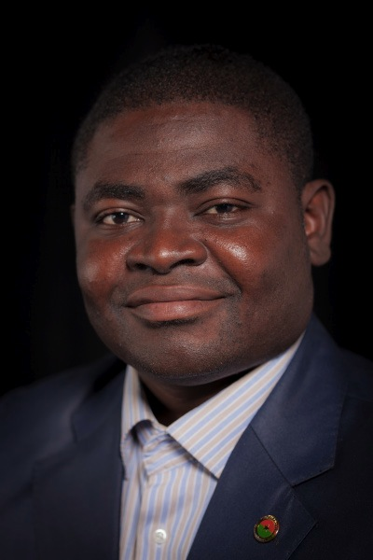
Issa Napon:
Le Chapeau du Chef, by: Smarty (http://tinyurl.com/pkpqpt6)

“This song describes with wonderful rhetoric how most leaders in Africa mislead their country or community.”

Attaches:
Darby Fitzgerald:
Man! I Feel Like a Woman, by: Shania Twain (http://tinyurl.com/buve9h6)

“Every time I hear this song it instantly puts me in a good mood. It reflects strength in being who you are while still having fun and not taking yourself too seriously.”

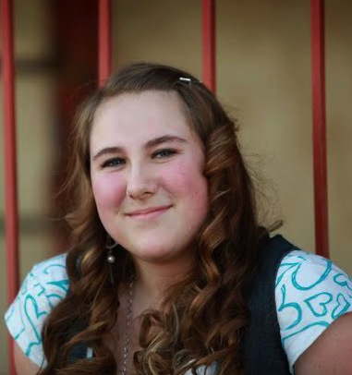
Aimee Cash:
Flaws, by: Bastille (http://tinyurl.com/pq3dk9s)

“This song reminds me that we are not always perfect, and it is those so-called ‘imperfections’ that make us who we are.”

Caitlin Cruz:
It’ll All Work Out, by: Tom Petty and the Heartbreakers (http://tinyurl.com/omh79jq)

“The song itself is fairly morose, but I love the final message: It’ll all work out.”

Sophia Mayberry:
I Believe I Can Fly, by: R. Kelly (http://tinyurl.com/q2k8nwd)

“This song has a special place in my heart. My dad used to play it for me all the time. My parents always tell me that I can do anything I put my mind to.”

Domenico Nicosia:
That’s Life, by: Frank Sinatra (http://tinyurl.com/o5nm3fw)

“When I am feeling down and not confident in myself or my situation, it helps to listen to this song and become lost in the lyrical perfection and musical composition.”

Tayllor Lillestol:
Odds Are, by: Barenaked Ladies (http://tinyurl.com/oyhrvk4)

“This is one of my favorite songs because it reminds me that crazy things may happen in this world, but there’s no reason to lose hope. It’s a cheerful song that’s bound to make your day better when you hear it.”

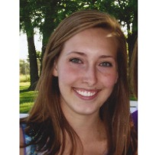
Emily Fritcke:
Dancing in the Moonlight, by: King Harvest (http://tinyurl.com/q6tpcbf)

“Fun fact: This song was played as a wake-up call for astronaut Daniel Tani of the STS-120 discovery mission headed to the International Space Station.”

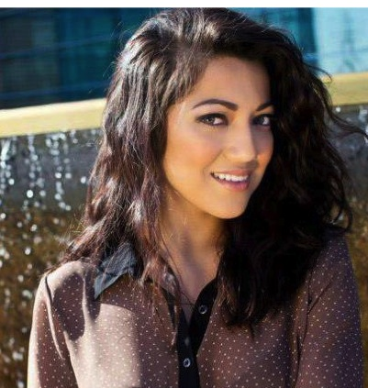
Shirin Ahmadpour:
Don’t Stop Believing, by: Journey (http://tinyurl.com/oqvk3c8)

“This song is the anthem to my life and can be heard all over the world. I love this song because it speaks truth and always motivates me to push forward and strive for success.”

Sammi Davis:
Diva, by: Beyonce (http://tinyurl.com/pztpwcf)

“I hate choosing my favorites of anything but I love Beyonce, and this song is all about being a strong woman.”

Staff:

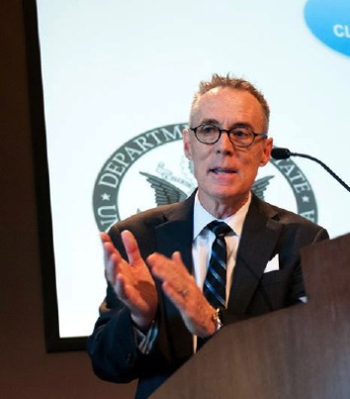
Dr. Bill Silcock:
Professional Jealousy, by: Van Morrison (http://tinyurl.com/pvudk4y)

“Among the over 5,000 vinyls in my collection whose poetic lyrics teach power lessons about leadership, perhaps none is more powerful than professional jealousy, a trait that can be the downfall of a business or a nation.”

Kristi Kappes:
Season of Love, by: Rent (http://tinyurl.com/pz7qsaa)

“I love musicals, but I especially love this song because it reminds me to treasure each moment, the good and the bad, and to be thankful for it all.”

