Prof Wangari Maathai case study of global leader

The 2004 Nobel Peace Laureate was the first African woman to receive the prize.

- 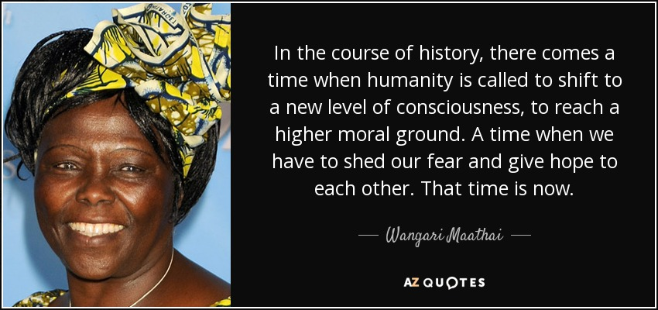In the course of history, there comes a time when humanity is called to shift to a new level of consciousness, to reach a higher moral ground. A time when we have to shed our fear and give hope to each other. That time is now.
- You can make a lot of speeches, but the real thing is when you dig a hole, plant a tree, give it water, and make it survive. That's what makes the difference
Wangari Maathai
Real, Future, Differences
save quote report
- You cannot protect the environment unless you empower people, you inform them, and you help them understand that these resources are their own, that they must protect them.”When we plant trees, we plant the seeds of peace and seeds of hope.
Wangari Maathai
Tree, Climate, Plant
save quote report
- You cannot enslave a mind that knows itself. That values itself. That understands itself.
Wangari Maathai
Mind, Knows, Values
save quote report
- No matter who or where we are, or what our capabilities, we are called to do the best we can.
Wangari Maathai
Matter, Capability, Do The Best
save quote report
- Sometimes we become bound by other people's thoughts because we are not sure about ourselves.
Wangari Maathai
People, Sometimes, Not Sure
save quote report
- I want to do the right things - I want to plant trees, I want to make sure that the indigenous forests are protected because I know, whatever happens, these are the forests that contain biodiversity, these are the forests that help us retain water when it rains and keep our rivers flowing, these are the forests that many future generations will need.
Wangari Maathai
Rain, Rivers, Water
save quote report
- Every one of us can make a contribution. And quite often we are looking for the big things and forget that, wherever we are, we can make a contribution. Sometimes I tell myself, I may only be planting a tree here, but just imagine what's happening if there are billions of people out there doing something. Just imagine the power of what we can do.
Wangari Maathai
Peace, People, Tree
save quote report
- It is evident that many wars are fought over resources which are now becoming increasingly scarce. If we conserved our resources better, fighting over them would not then occur…so, protecting the global environment is directly related to securing peace…those of us who understand the complex concept of the environment have the burden to act. We must not tire, we must not give up, we must persist.
Wangari Maathai
Giving Up, War, Fighting
save quote report
- Today we are faced with a challenge that calls for a shift in our thinking, so that humanity stops threatening its life-support system. We are called to assist the Earth to heal her wounds and in the process heal our own - indeed to embrace the whole of creation in all its diversity, beauty and wonder. Recognizing that sustainable development, democracy and peace are indivisible is an idea whose time has come
Wangari Maathai
Thinking, Ideas, Support Systems
save quote report
- Education, if it means anything, should not take people away from the land, but instill in them even more respect for it, because educated people are in a position to understand what is being lost. The future of the planet concerns all of us, and all of us should do what we can to protect it. As I told the foresters, and the women, you don't need a diploma to plant a tree.
Wangari Maathai
Mean, Land, People
save quote report
- What a friend we have in a tree, the tree is the symbol of hope, self improvement and what people can do for themselves.
Wangari Maathai
Peace, Self, People
save quote report
- Every person who has ever achieved anything has been knocked down many times. But all of them picked themselves up and kept going, and that is what I have always tried to do.
Wangari Maathai
Climate Change, Knocked Down, Persons
save quote report
- We tend to put the environment last because we think the first thing we have to do is eliminate poverty. But you can't reduce poverty in a vacuum. You are doing it in an environment.
Wangari Maathai
Thinking, Vacuums, Lasts
save quote report
- I’m very conscious of the fact that you can’t do it alone. It’s teamwork. When you do it alone you run the risk that when you are no longer there nobody else will do it.
Wangari Maathai
Teamwork, Running, Risk
save quote report
- I have always felt that perhaps women have sometimes almost embraced the same values as men, and the same character as men, because they are in the men's world, and they are trying to fit into a system that men have created. And maybe in truth when there is a critical mass of women who play that role in governments, then we will see whether women can really manage power in a way that is less destructive than the way that men have used power.
Wangari Maathai
Character, Men, Play
save quote report
- Human rights are not things that are put on the table for people to enjoy. These are things you fight for and then you protect.
Wangari Maathai
Fighting, Rights, People
save quote report
- African women in general need to know that it's OK for them to be the way they are - to see the way they are as a strength, and to be liberated from fear and from silence.
Wangari Maathai
Happiness, Inspiring, Success
save quote report
- I stand before you and the world humbled by this recognition and uplifted by the honour of being the 2004 Nobel Peace Laureate. As the first African woman to receive this prize, I accept it on behalf of the people of Kenya and Africa, and indeed the world. I am especially mindful of women and the girl child. I hope it will encourage them to raise their voices and take more space for leadership.
Wangari Maathai
Girl, Children, Voice
save quote report
- I don't really know why I care so much. I just have something inside me that tells me that there is a problem, and I have got to do something about it. I think that is what I would call the God in me.
Wangari Maathai
Thinking, Care, Problem
save quote report
- We cannot tire or give up. We owe it to the present and future generations of all species to rise up and walk!
save quote report
- It is very important for young people not to be afraid of engaging in areas that are not common to the youth. Get involved in local activities, get involved in local initiatives, be involved in leadership positions because you can’t learn unless you are involved. And if you make mistakes that is alright too because we all make mistakes and we learn from those mistakes. You gain confidence from learning, failing and rising again.
Wangari Maathai
- Those of us who witness the degraded state of the environment and the suffering that comes with it cannot afford to be complacent. We continue to be restless. If we really carry the burden, we are driven to action. We cannot tire or give up. We owe it to the present and future generations of all species to rise up and walk!

- We are called to assist the Earth to heal her wounds and in the process heal our own – indeed, to embrace the whole creation in all its diversity, beauty and wonder. This will happen if we see the need to revive our sense of belonging to a larger family of life, with which we have shared our evolutionary process.
"One of the reasons why we started the Green Belt Movement is to work with these ordinary peasant farmers so as to educate them that, despite the fact that they are poor, it is in their interest to protect the soil that they have, to protect the forest they have, to protect the land that they have, because if they don't do it, things can be only worse tomorrow for them for them and for their children."
- Wangari Maathai,

